Mythe Farm Accommodation Terms and Conditions
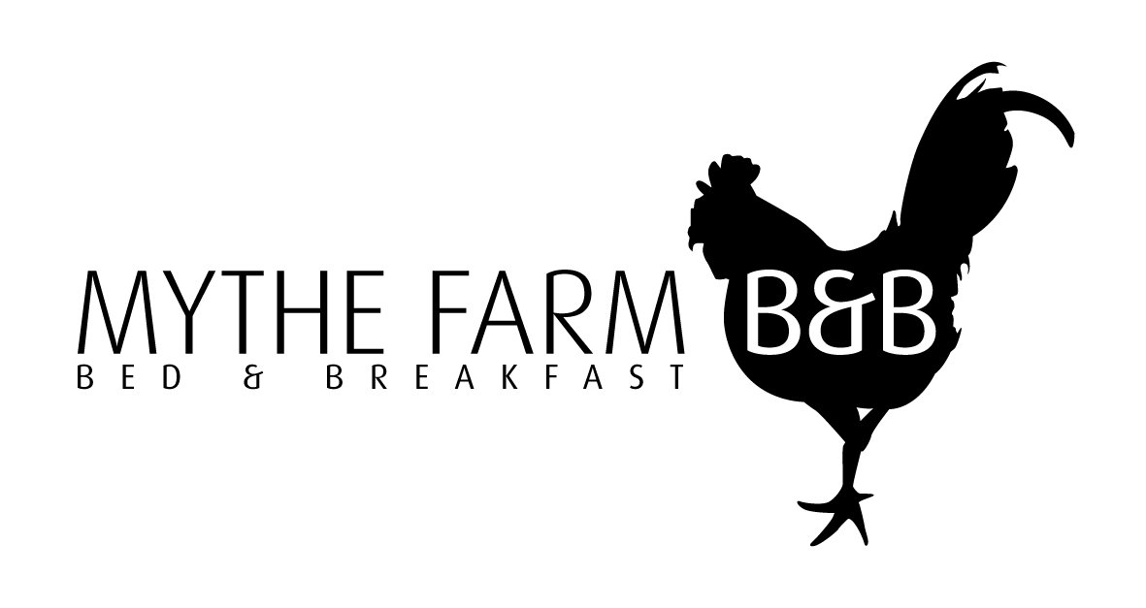
For your own understanding and peace of mind please read through the details below. It is a good idea to forward a copy to your guests for their information.

Information about us: We are Mythe Farm Limited, a company registered in England and Wales whose registered address is at Pinwall Lane, Sheepy Magna, Atherstone, Warwickshire, CV9 3PF (We/ Us). You can contact us by writing (including by email) or by telephoning us using the contact details above.

Parking: Parking for accommodation is in the main Mythe Barn car park.

Check In from 12:00pm: Accommodation will be available from midday onwards on your check-in day. Keys will be available at reception and guests are requested to collect their key as soon as possible after this time.

Breakfast In The Barn at 8:15am: A continental breakfast will be available in the barn from 8:15am until 9:00am. Please provide details of any special dietary requirements when paying.

Check out is by 10:00am: Accommodation must be vacated by 10am on your check-out day. Please leave keys in the bedroom or on the bar.

Bookings: Our acceptance of your order will take place when we send you an email confirming your order, at which point a contract will come into existence between us.

If you are a business and have booked accommodation as part of a corporate ‘event or programme’ the contract will be formed in accordance with the relevant contract terms for the corporate event or programme.

Prices and Payment: all published prices, on our website or otherwise, are inclusive of VAT, where applicable. Unless otherwise agreed, all payments should be paid in full and in advance, at the time of booking.

Children: We welcome children of all ages.

Alcohol: Only alcohol purchased at Mythe Barn may be consumed on the premises. Mythe Barn is a licensed premises, if you bring alcohol to Mythe Farm and/or Mythe Barn it will be confiscated or you may be asked to leave. To avoid disappointment and help to ensure everyone has an enjoyable time please observe this policy.

Smoking: Smoking is not permitted inside the accommodation. If we find that guests, have been smoking anywhere inside the accommodation we reserve the right ask guests, to leave immediately. In such circumstances, you will remain liable for the whole of the cost of your stay. We also reserve the right to charge a sum equivalent to one night’s stay if we are unable to re-let the room for 24 hours whilst it is fully aired or deep cleaned as a result of smoking. You will be notified in writing as soon as is reasonably practicable if evidence of smoking is discovered after you depart.

Pets: Pets are not allowed other than guide dogs in any of the accommodation.

Damages and Breakages: We take pride in providing well maintained accommodation and we ask guests to take care when staying in our rooms. Please report any incidents or breakages as soon as possible after they occur. We do not normally charge for minor breakages or damage, but we reserve the right to request a deposit ahead of your stay to secure a booking and/or to send you an invoice for repair or making good if the damage or breakage is significant. You will be responsible and liable for any damage caused to, or theft from, the property or its contents caused by you or any guests you are responsible for or any other person visiting your room and you agree to indemnify us in this regard for all reasonably incurred losses.

Personal Property: We do not accept any responsibility for any loss of, damage to or theft of any personal belongings.

Extra Cleaning Charges: We reserve the right to charge an additional 25% of the total accommodation price, for any extra cleaning that may be required, as a result of soiling, caused by illness or otherwise. A 25% charge will be applied per incident plus any additional charges for cleaning affected bed throws, carpets, cushions etc.

Privacy Policy: Data collected during the course of this booking will be stored by us in accordance with relevant laws. We will not share your details with any third party.

Cancellation and Insurance: If you are a consumer and have made your booking at a distance (including on-line or over the phone) you will have up to 14 days in which to cancel your order and receive a full refund. If you cancel your booking within 7 days of your check-in date and we are subsequently unable to re-let the room, you accept that we may, at our discretion, refuse to refund all or part of the cost for the room unless you are within your 14 day cancellation period.

In all other circumstances, payments are non-refundable and non - transferrable. We advise taking out holiday insurance should you need to cancel.

Amendments By Us: If you have booked a specific room we will try to ensure that this room is available to you. We do however reserve the right to accommodate you in a different room if circumstances require. If the alternative room is not acceptable to you, you have the right to treat the booking as being cancelled and we will refund all monies already paid by you and confirm that you will not be liable for any further payments to us. If you accept the new room and the new room is normally charged at a lower rate, then the difference will be deducted from the final balance due or refunded to you if already paid. If the new room is normally charged at a higher rate then you will not be charged the difference. This is the limit of our liability to you in these circumstances.

Amendments by You: if you wish to make a change to your booking please contact us by writing (including by email) or telephoning using the contact details above. We will let you know if the change is possible. If it is, we will let you know about any changes to the price. If we cannot accommodate the change or the consequences of making the change are not acceptable to you, you may need to cancel the booking.

Non-Availability: Should any booked accommodation be unavailable for any reason we will attempt to offer you alternative accommodation. If this is not possible or the alternative is not acceptable to you then we will refund all monies paid by you for the accommodation. This is the limit of our liability to you in these circumstances.

YOUR ATTENTION IS DRAWN IN PARTICULAR TO THIS CLAUSE: Limitation of our Liability: We do not accept liability for any damage, loss or injury to any member of your party or any vehicles, possessions or other property, unless proven to be caused by our negligence. Other than for death or personal injury caused by our negligence or any losses caused by fraud or fraudulent misrepresentation, our total liability to you shall not exceed the total price received by you under the contract.

If you are a business, we shall, under no circumstances, be liable to you whether in contract or tort (including negligence), breach of statutory duty, or otherwise for any business losses, including for any loss of profit, or any indirect or consequential loss arising under or in connection with the contract.

If you are a business and have booked accommodation as part of a corporate event or programme, the terms contained in the relevant contract for the corporate event or programme (including, but not limited to, those relating to our limitation of liability) will prevail in the event that there is a conflict between those terms and these.

Severance: Each of these paragraphs operates separately. If any court or relevant authority decides that any of them are unenforceable, the remaining paragraphs will remain in full force and effect.

Third Party Rights: This contract is between you and us. Unless otherwise agreed, no other person shall have any rights to enforce any of its terms.

Governing Law: these terms are governed by English Law and you can bring legal proceedings in respect of the services provided in the English Courts.

